Review of DRAFT 9-10-18 - Jean B
Page | Comment
1 | No change except for final date
2 | I added Ron Miguel’s suggestion to add: “without the approval of the board”  I accept the rest of the page
3 | The text of board composition was voted on and approved a board meeting  on December 13, 2017. I copied it below. I think no changes are necessary and we should put the version 1.5 text back in.  GBD Bylaws Version 1.5:  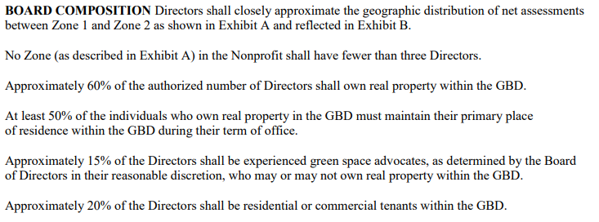
4 | The first sentence belongs to section 5.3 and should be replaced by the text in Bylaws 1.5 BOARD COMPOSITION as described above.  Green Space Advocates should not be”or at large”.  Green Space Advocate - The Green Space Advocate board seat is reserved for  members who have substantial experience advocating for environmentally sound land use including the areas:  - Park creation, upgrading, maintaining  - Green Space creation, upgrading, maintaining  - Water and waste management, recycling, capturing  - Protecting and insuring Clean air
5 | Accept as is
6 | I changed “handled” to “determined“ in Section 6.4  I added “agenda” before a vote to section 7.3  The rest of the page is ok with me.
7 | Accept as is
8 | I added Julie’s suggestion :  “The treasurer shall insure that relevant GBD financial records are available for an annual audit or audit review prepared by an outside CPA.”  All else if Ok
9 | I added section 8.5-8.7 as requested at the last meeting.  I accepted Julie’s recommendation and replaced “a purely “ with “in an “ in section 8.8  Rest of it is OK with me
10 | Section 9.1 – I added as often as possible  I deleted “filling of any Board vacancies” and resolved Julies comment  Rest of the page is ok by me
11 | OK
12 | OK
13 | OK

